Experiment 7
Aim
Auto Scaling in Kubernetes
Theory
Kubernetes is an open-source container orchestration platform used to automate the deployment, scaling, and management of containerized applications. It provides features such as load balancing, self-healing, service discovery, and resource management, ensuring that applications remain available and responsive under varying workloads.
Horizontal Pod Autoscaler (HPA) is a Kubernetes resource that automatically increases or decreases the number of pod replicas based on observed resource utilization, such as CPU or memory usage. It eliminates the need for manual scaling and helps maintain application performance while utilizing resources efficiently.
Working of HPA
HPA continuously monitors resource metrics and compares them with a predefined target. It uses the following components:
- Metrics-server: Collects CPU and memory usage information from Kubernetes nodes and pods.
- Deployment: Manages the application pods and allows Kubernetes to adjust their replica count.
- HPA Controller: Calculates the desired number of replicas based on current resource utilization and the target.
- Service: Provides a stable network endpoint through which requests are directed to the application pods.
For example, if CPU utilization reaches 100% while the target is 50%, HPA may double the number of replicas. The final replica count is restricted by the configured minimum and maximum limits.
Scaling Behaviour
HPA exhibits two main behaviours:
- Scale-up: When CPU utilization exceeds the target, HPA increases the number of pod replicas to distribute the workload.
- Scale-down: When CPU utilization decreases, HPA reduces the number of replicas to avoid unnecessary resource consumption.
A stabilization window can be configured to prevent frequent changes in replica count due to temporary fluctuations in workload. Thus, the experiment demonstrates how Kubernetes automatically adjusts application capacity according to workload demand, improving resource utilization, responsiveness, and scalability while minimizing manual intervention.
Execution
#cpu-app.yaml  apiVersion: apps/v1  kind: Deployment  metadata:  name: cpu-app  spec:  replicas: 1  selector:  matchLabels:  run: cpu-app  template:  metadata:  labels:  run: cpu-app  spec:  containers:  - name: cpu-app  image: cpu-app:1.0  imagePullPolicy: Never  ports:  - containerPort: 80  resources:  requests:  cpu: 200m  limits:  cpu: 500m  ---  apiVersion: v1  kind: Service  metadata:  name: cpu-app  labels:  run: cpu-app  spec:  ports:  - port: 80  selector:  run: cpu-app | #hpa.yaml  apiVersion: autoscaling/v2  kind: HorizontalPodAutoscaler  metadata:  name: cpu-app  spec:  scaleTargetRef:  apiVersion: apps/v1  kind: Deployment  name: cpu-app  minReplicas: 1  maxReplicas: 10  metrics:  - type: Resource  resource:  name: cpu  target:  type: Utilization  averageUtilization: 50  behavior:  scaleDown:  stabilizationWindowSeconds: 60  scaleUp:  stabilizationWindowSeconds: 0

Output
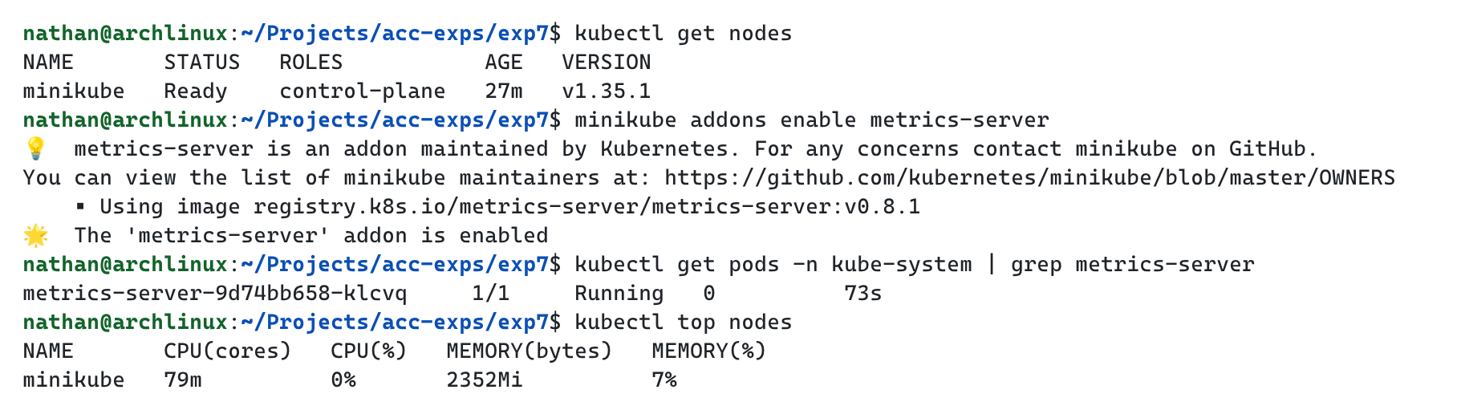

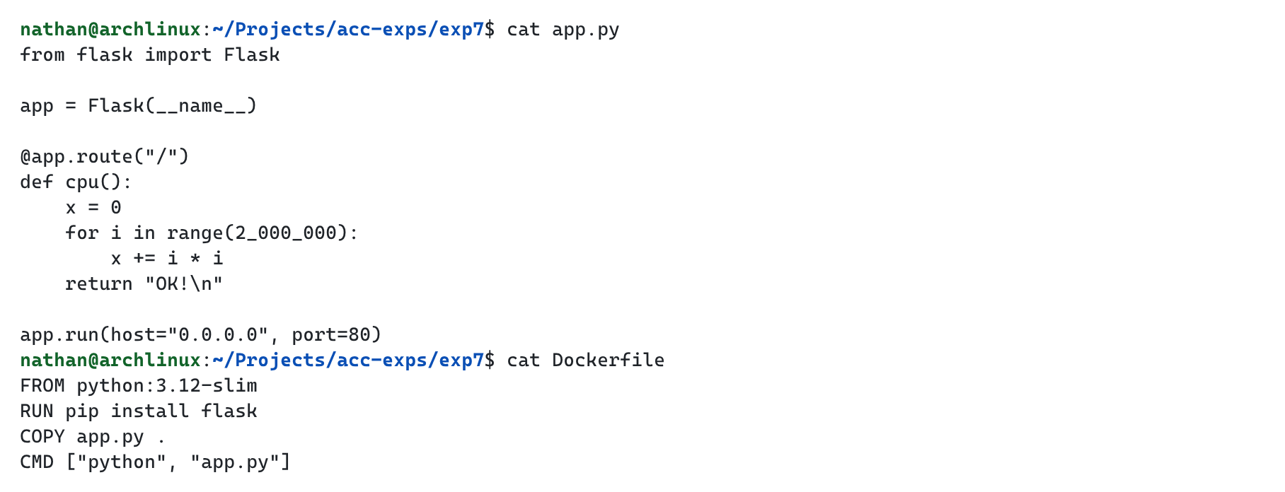

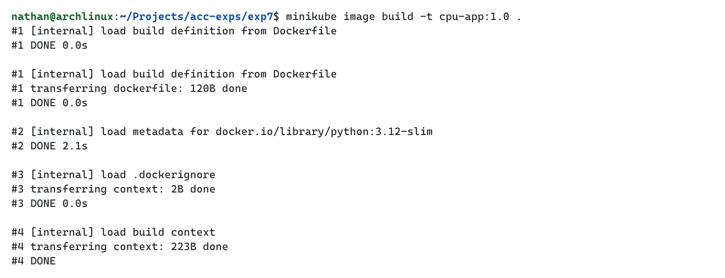

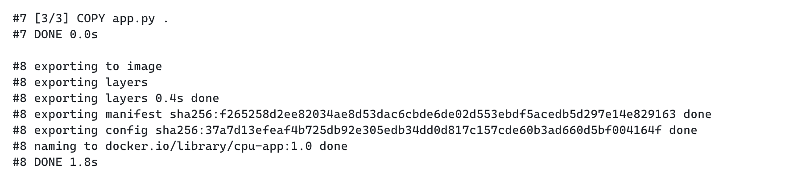

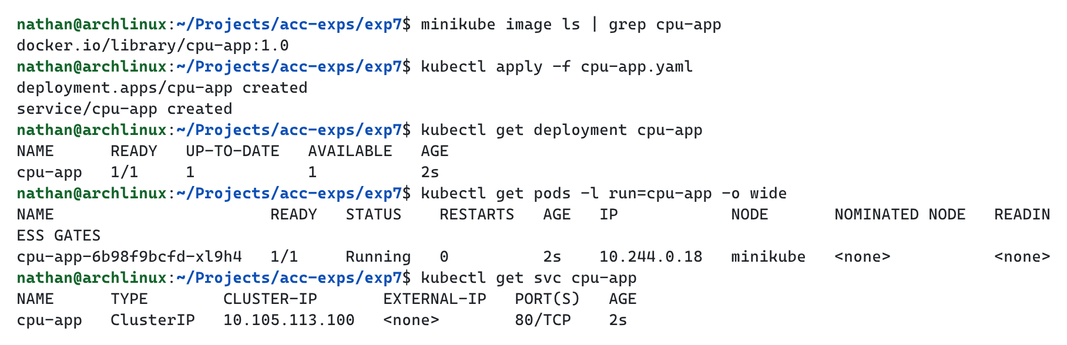

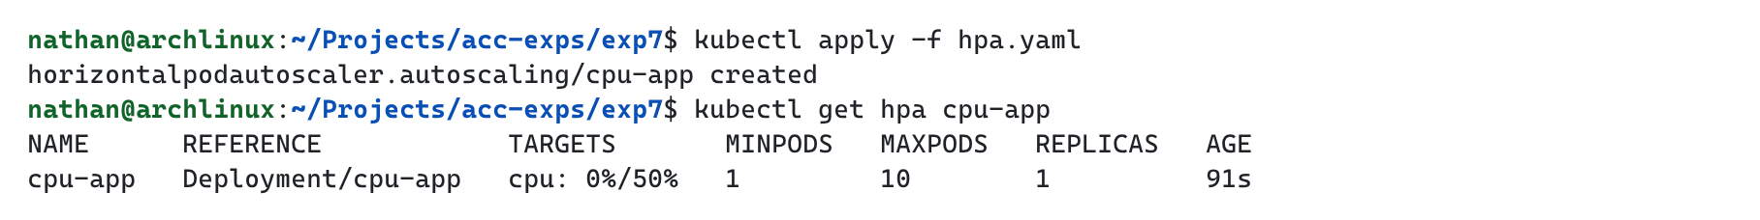

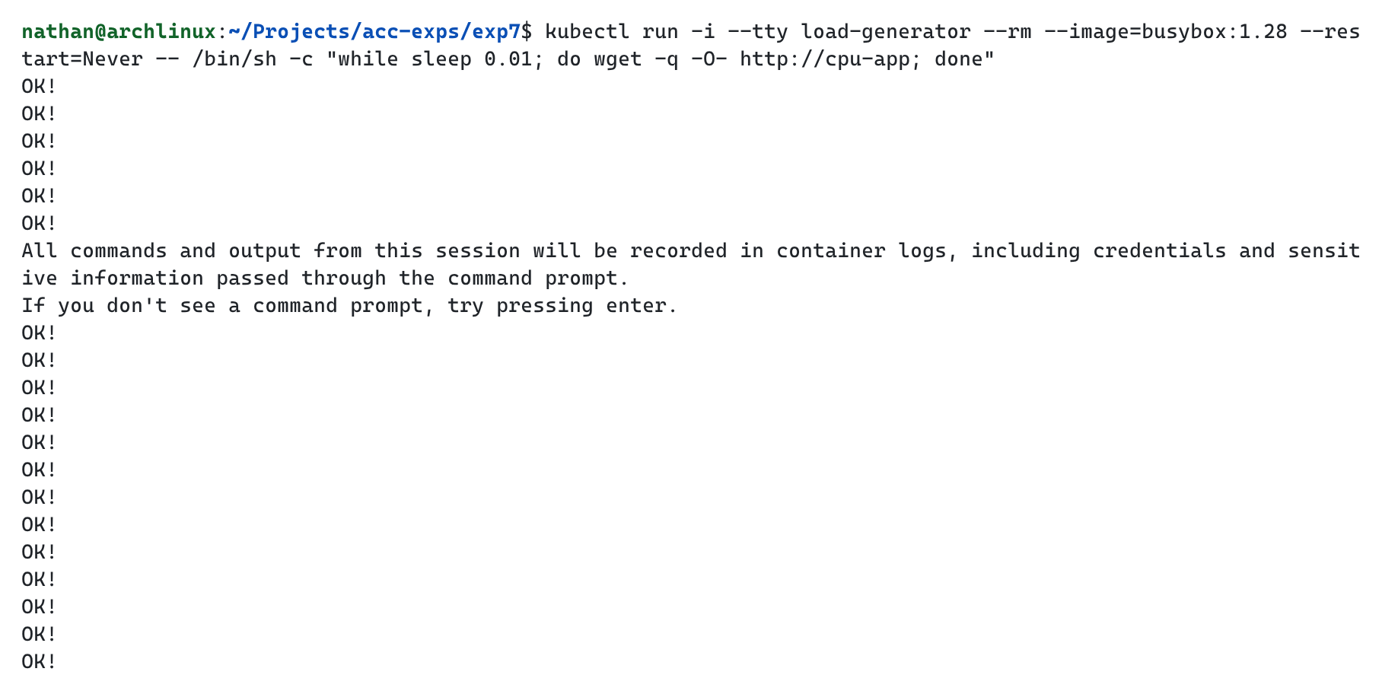

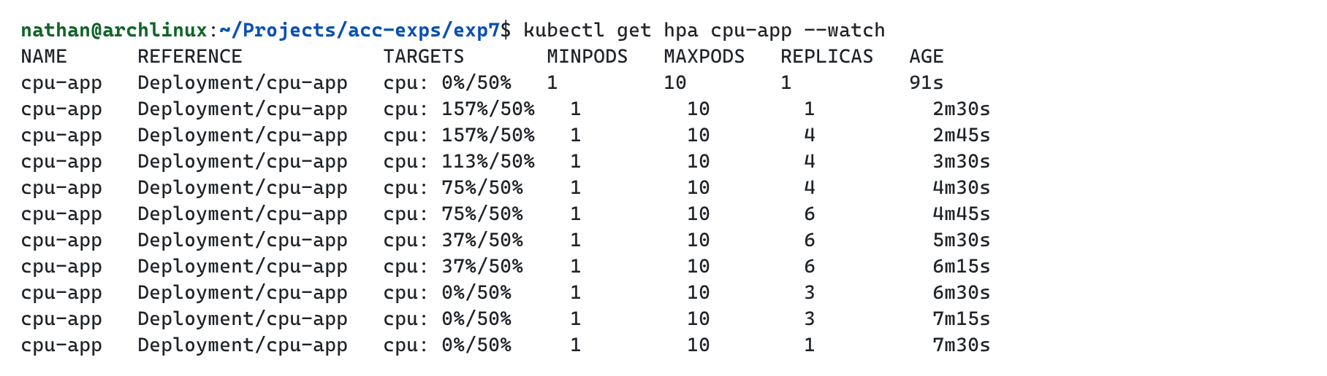

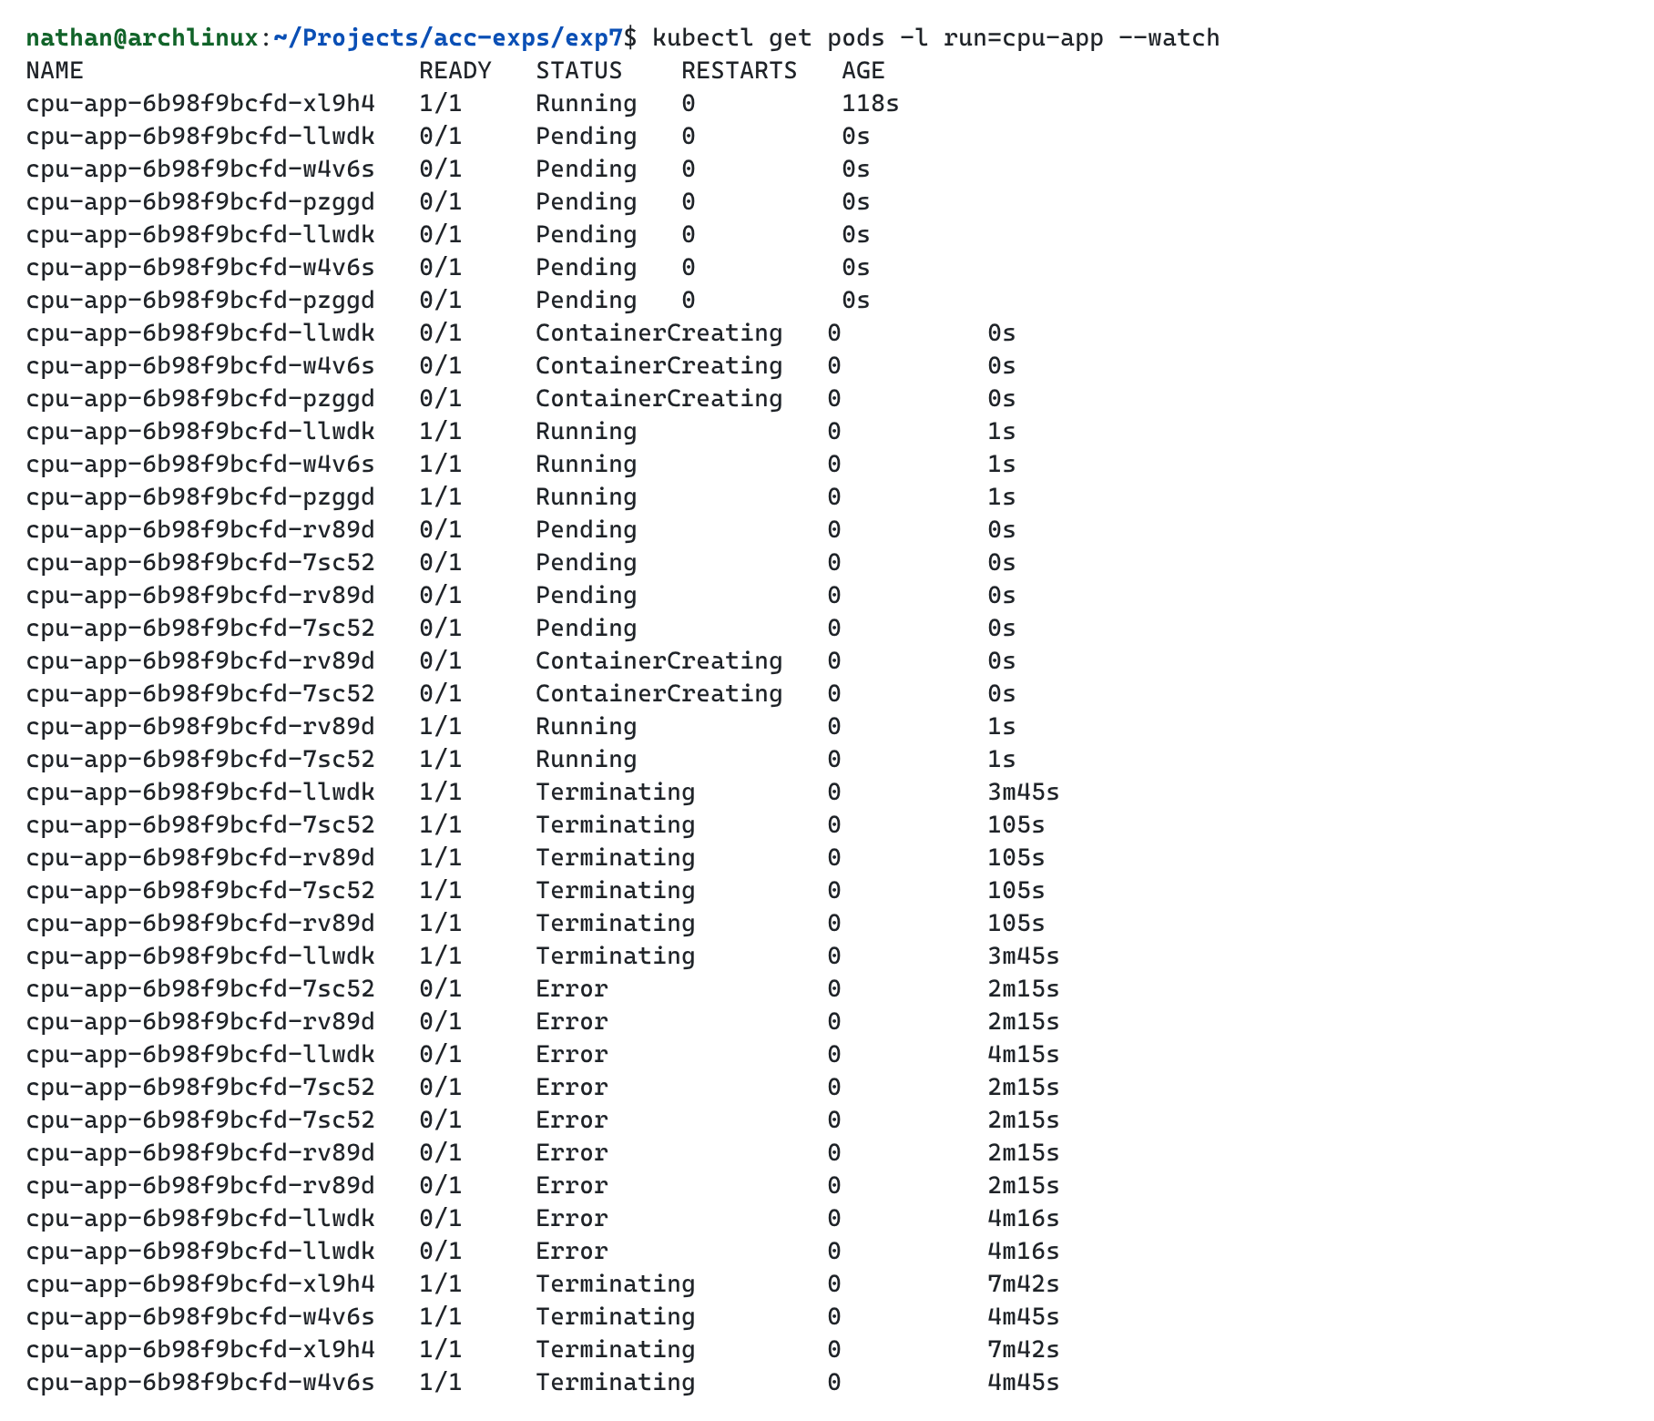

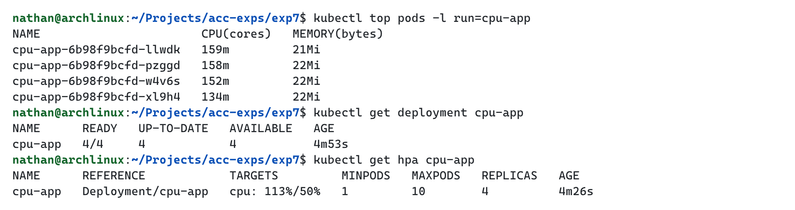

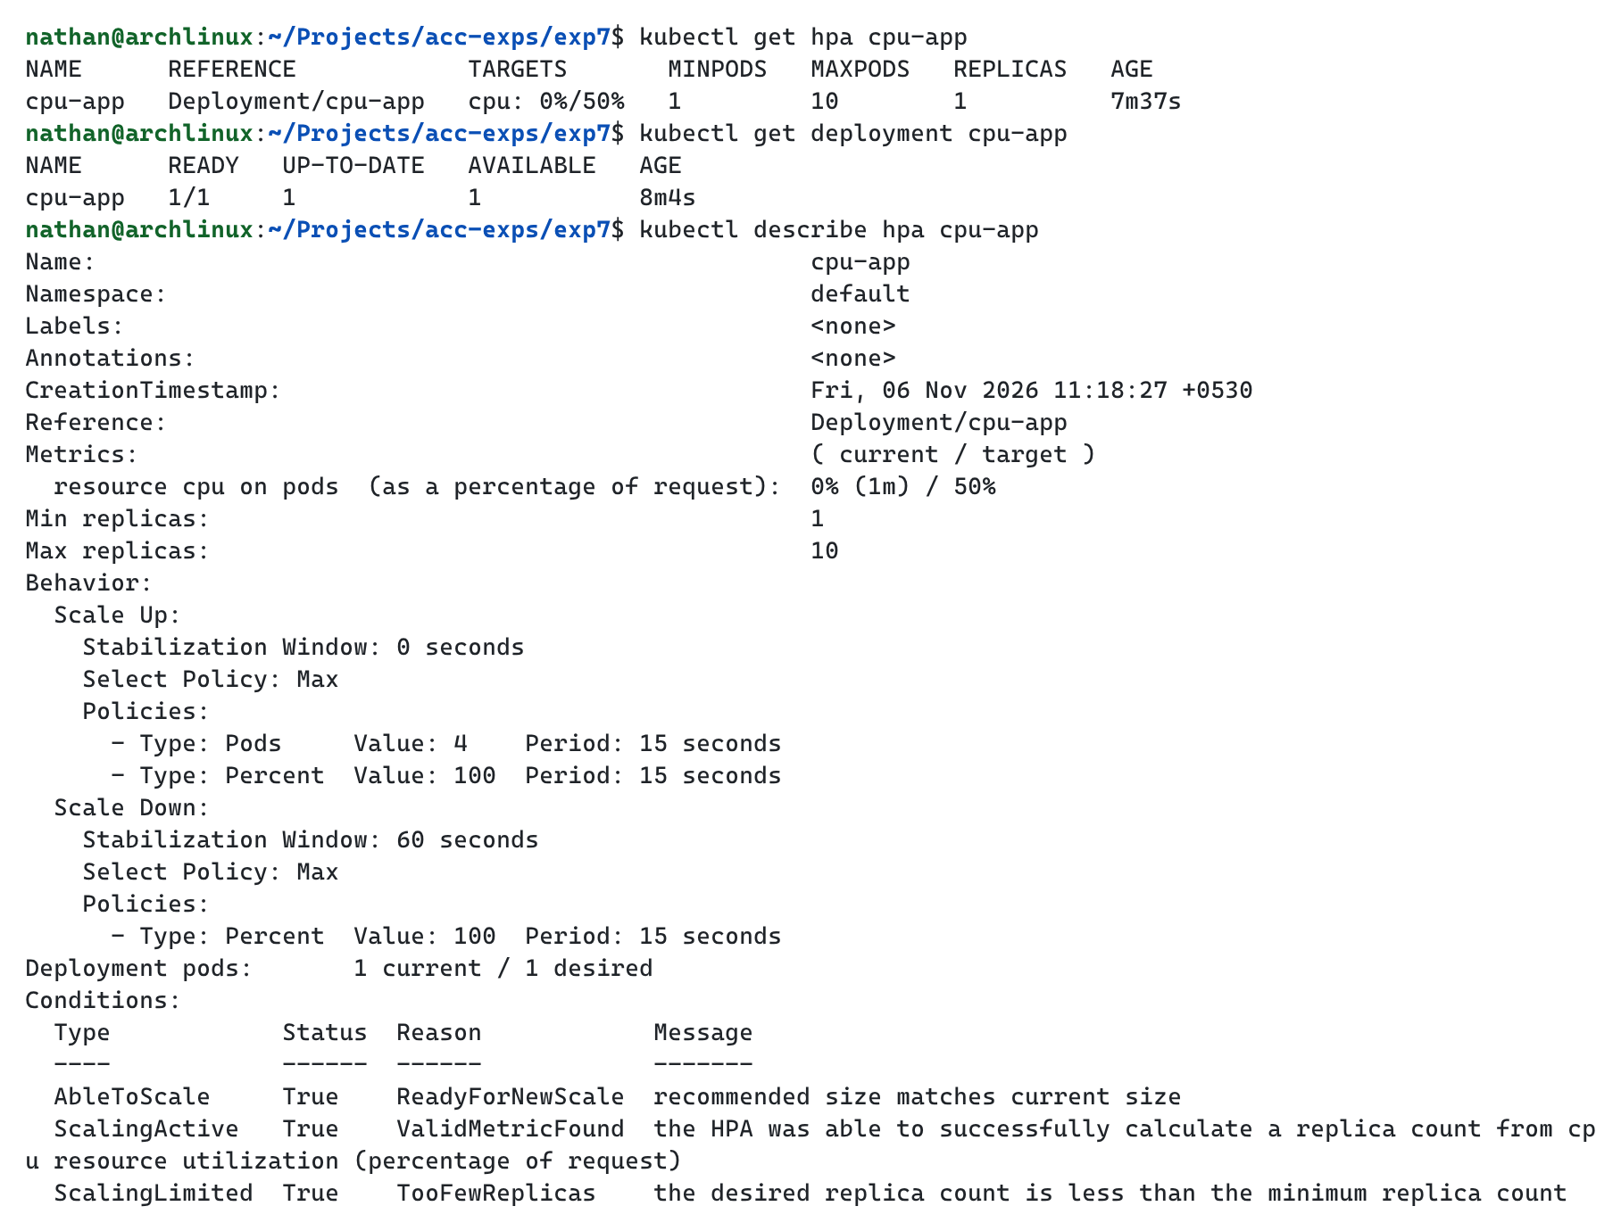

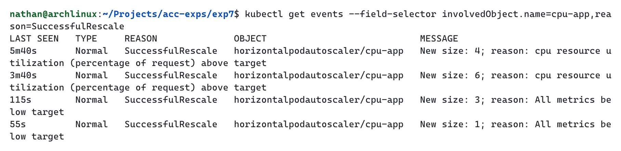

Conclusion
Thus, the experiment successfully demonstrated Auto Scaling in Kubernetes using the Horizontal Pod Autoscaler. When the load generator raised CPU utilization to 157% against the 50% target, HPA scaled the cpu-app Deployment from 1 replica to 4 and then 6, bringing utilization down to 37%. After the load was removed and the stabilization window had passed, HPA scaled the Deployment back down to 3 replicas and then to 1, showing that capacity follows workload demand without manual intervention.

